**Assignment 1**

**Due**: 11:55PM September 11, 2023

**Submission**: Complete your submission on Blackboard.

Email submission will NOT be accepted. If you cannot complete the assignment before the deadline due to Covid-19, you must contact the instructor **BEFORE** the deadline. Otherwise, **late submission will NOT be accepted**.

Total points: 20 points

1. Simulate the execution (contents in memory and registers in hexadecimal)

Both instructions and data are 16 bits long. The instruction format provides 4 bits for the opcode, and the remaining 12 bits can be directly addressed.

**The list of opcodes:**

0x01 = Load AC from Memory

0x02 = Store AC to Memory

0x03 = Load AC from I/O (e.g., 3005: Load AC from I/O device 5)

0x05 = Add to AC from Memory

0x07=Store AC to I/O (e.g., 7006: Store AC to I/O device 6)

Memory

…

202

2010

2501

5500

200

3005

500

0005

501

Assume the value retrieved from device 5 is 0x2. The value in the PC is 200.

1.1. Simulate the execution: List the values in PC, AC and IR in both fetch and execute cycles for each instruction. (10 points)

|  |  |
| --- | --- |
| **Stage** | Fetch |
| **PC** | 200 |
| **AC** | 0 |
| **IR** | 3005 |

|  |  |
| --- | --- |
| **Stage** | Execute |
| **PC** | 201 |
| **AC** | 2 |
| **IR** | 3005 |

|  |  |
| --- | --- |
| **Stage** | Fetch |
| **PC** | 201 |
| **AC** | 2 |
| **IR** | 5500 |

|  |  |
| --- | --- |
| **Stage** | Execute |
| **PC** | 202 |
| **AC** | 7 |
| **IR** | 5500 |

|  |  |
| --- | --- |
| **Stage** | Fetch |
| **PC** | 202 |
| **AC** | 7 |
| **IR** | 2501 |

|  |  |
| --- | --- |
| **Stage** | Execute |
| **PC** | 203 |
| **AC** | 7 |
| **IR** | 2501 |

1.2. What is the value in address 501 at the end of the execution. (1 point)

The value in address 501 at the end of the execution is 7.

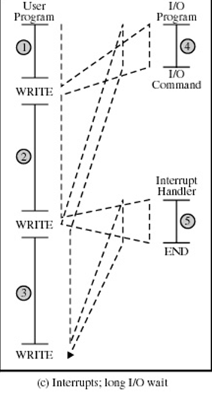

2. When an i/o operation is called, it takes three steps to complete the operation: (1) prepare the i/o operation on the software level (defined in code block 4), (2) physical operations on the i/o device, and (3) complete the i/o operation on the software level (defined in code block 5, which is also interrupt handler). The code after an i/o operation is independent to the completion of the i/o operation. Please write down the simulation of program execution – the long i/o with interrupt. Clearly indicate the idle time on the CPU (if any) during the program execution. (6 points)

3. Temporal locality is one type of locality of reference.

**Temporal locality**: If at one point a particular memory location is referenced, then it is likely that the same location will be referenced again in the near future. There is temporal proximity between adjacent references to the same memory location.

Consider the following example:

for (i=0; i<10; i++)

a[i] = a[i]+1;

Give one example of the temporal locality in the above code. (3 points)

One example of temporal locality is how the same address a[i] is accessed twice in the same line. The program reads a[i], adds 1 to it, and stores it back to a[i].

Another example is how the same variable, ‘i’, is being accessed repeatedly.

END